System architecture overview – This diagram illustrates the interaction of the various component packages.
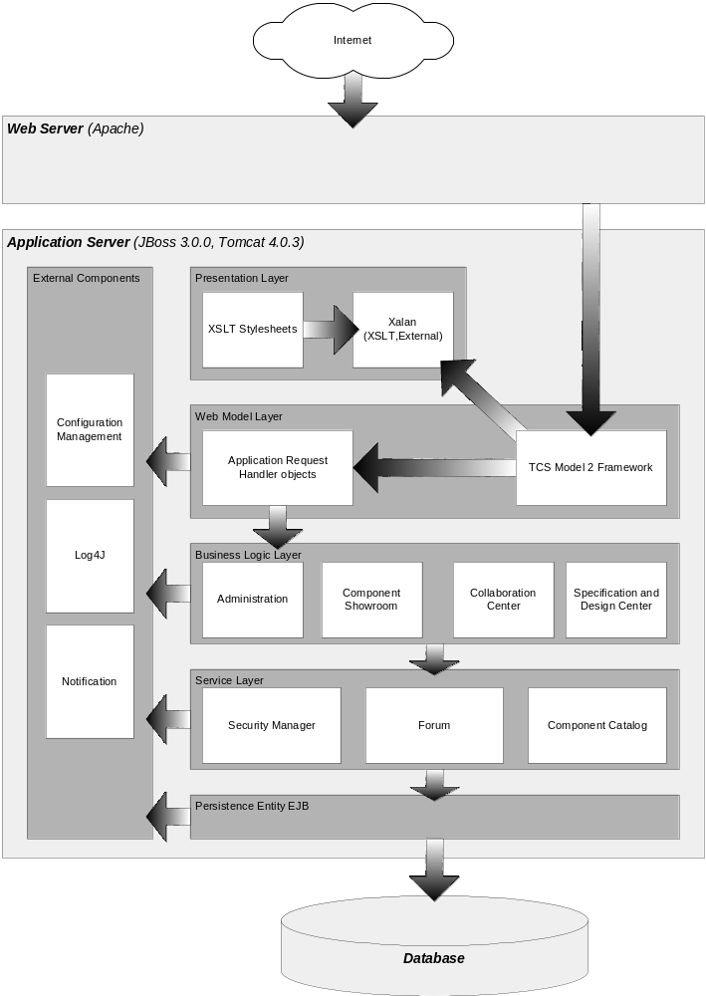
Description of the application layers

